POWER BI ASSIGNMENT-2

1.Explain the advantages of Natural Queries in PowerBi with an

example?

Sometimes the fastest way to get an answer from your data is to perform a search over your data using natural language. The Q&A feature in Power BI lets you explore your data in your own words using natural language. Q&A is interactive, even fun. Often, one question leads to others as the visualizations reveal interesting paths to pursue. Asking the question is just the beginning. Travel through your data, refining or expanding your question, uncovering new information, zeroing in on details, or zooming out for a broader view. The experience is interactive and fast, powered by an in-memory storage.

1. 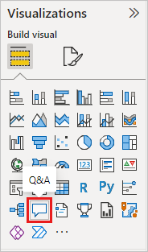Start on a blank report page and select the Q&A visual icon from the Visualizations pane.
2. 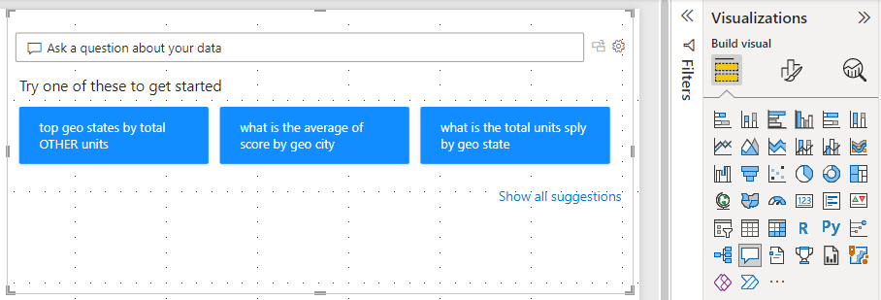Drag the border to resize the visual.
3. To create the visual, select one of the suggested questions or start typing in the question box. In this example, we've selected **top geo states by sum of revenue**. Power BI does its best to select which visual type to use. In this case, it's a map.

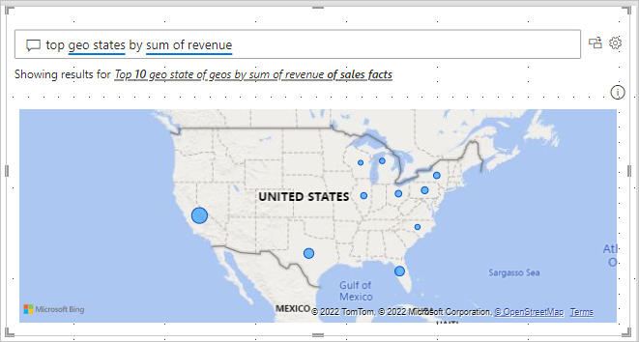

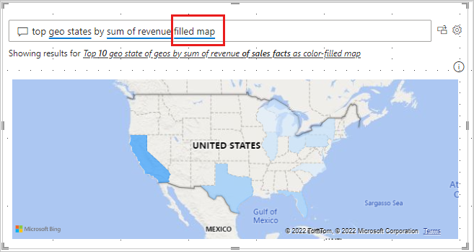But you can tell Power BI which visual type to use by adding it to your natural language query. Keep in mind that not all visual types will work or make sense with your data. For example, this data wouldn't produce a meaningful scatter chart. But it works as a filled map.

**Create a Q&A visual using a natural language query**

In the example above, we selected one of the suggested questions to create our Q&A visual. In this exercise, we'll type our own question. As we type our question, Power BI helps us with autocomplete, suggestion, and feedback.

If you're unsure what type of questions to ask or terminology to use, expand **Show all suggestions** or look through the Fields pane along the right side of the canvas. The Fields pane will get you familiar with the terms and content of the Sales & Marketing dataset.

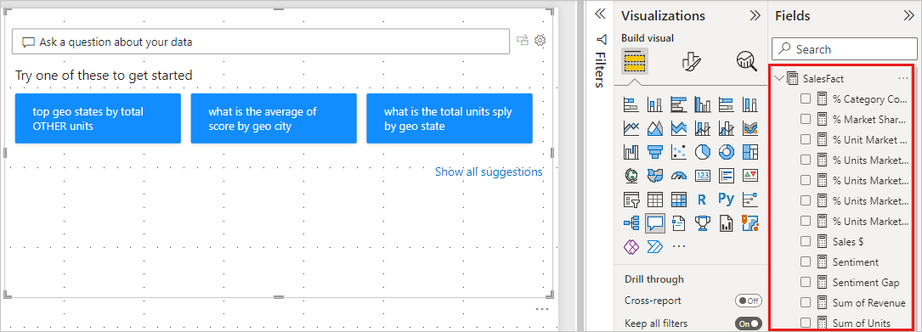

1. 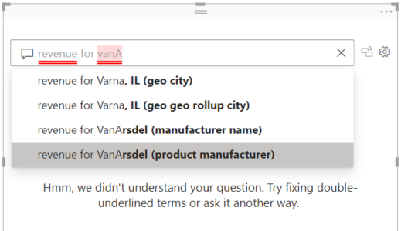Type a question in the Q&A field. Power BI adds a red underline to words it does not recognize. Whenever possible, Power BI helps define unrecognized words. In the first example below, selecting either of the last two suggestions will work for us.
2. As we type more of the question, Power BI lets us know that it doesn't understand the question, and tries to help. In the example below, Power BI suggests a different way to word our question using terminology from our dataset.

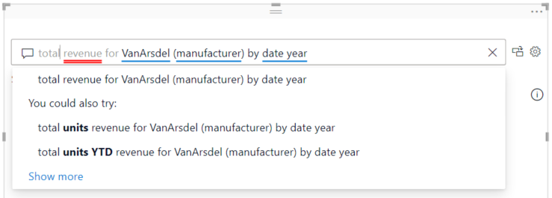

1. 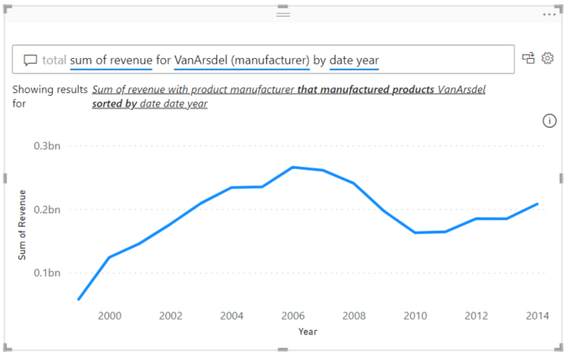With Power BI's help, we were able to ask a question with all recognizable terms. Power BI displays the results as a line chart.
2. Let's change the visual to a column chart.

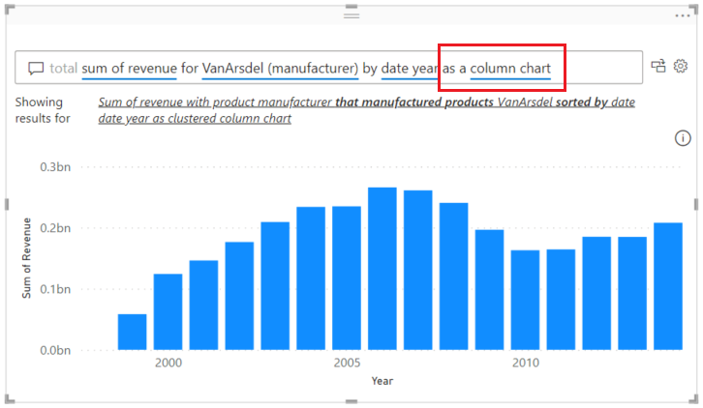

1. 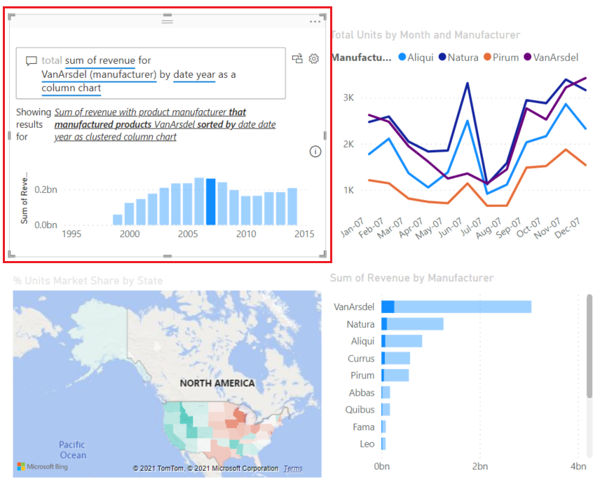Add more visuals to the report page and see how the Q&A visual interacts with the other visuals on the page. In this example, the Q&A visual has cross-filtered the line chart and map and cross-highlighted the bar chart.

1. Explain Web Front End(WFE) cluster from Power BI Service Architecture?

The **WFE** cluster uses Azure AD to authenticate clients, and provide tokens for subsequent client connections to the Power BI service. Power BI uses the **Azure Traffic Manager** (Traffic Manager) to direct user traffic to the nearest datacentre. Traffic Manager directs requests using the DNS record of the client attempting to connect, authenticate, and to download static content and files. Power BI uses the **Azure Content Delivery Network** (CDN) to efficiently distribute the necessary static content and files to users based on geographical locale.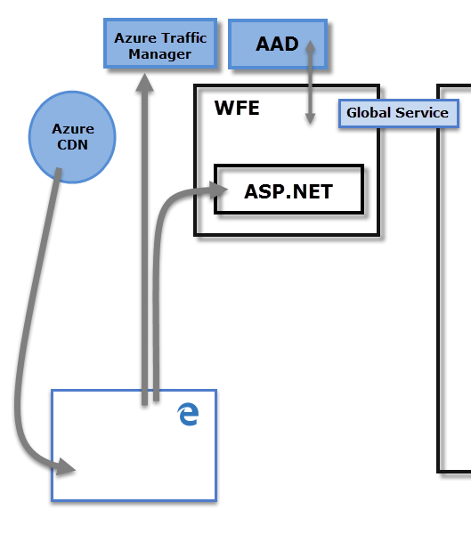

1. Explain Back End cluster from Power BI Service Architecture?

The **Back-End** cluster determines how authenticated clients interact with the Power BI service. The **Back-End** cluster manages visualizations, user dashboards, datasets, reports, data storage, data connections, data refresh, and other aspects of interacting with the Power BI service. The **Gateway Role** acts as a gateway between user requests and the Power BI service. Users don't interact directly with any roles other than the **Gateway Role**. **Azure API Management** eventually handles the **Gateway Role**

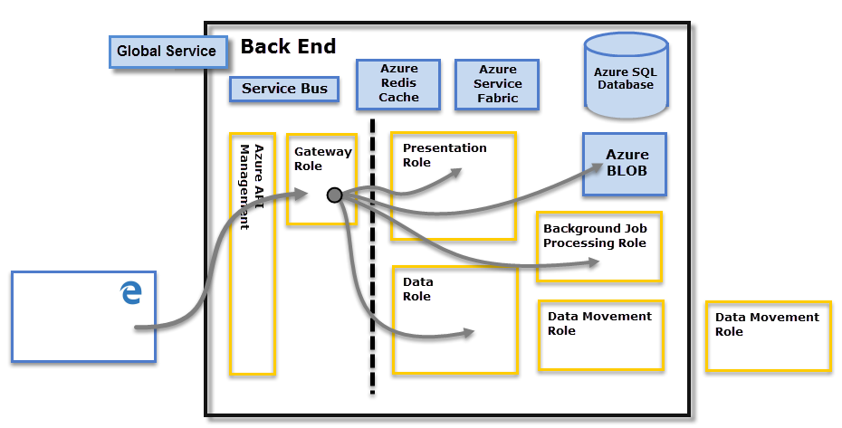

4.Compare Microsoft Excel and PowerBi Desktop on the following features:

Data import

Data transformation

Modeling

Reporting

Server Deployment

Convert Models

Cost

**Data Model**

Power BI is really focused on data ingest and building potentially complex data models easily.

Excel is totally focused on structured and simple[data models](https://www.educba.com/data-models-in-dbms/) with a wide range of features.

**Reports**

Excel reports are normal and ordinary comparing Power BI.

Power BI offers Beautiful branded reports comparing Excel.

| **Item** | **Power BI** | **Excel** |
| --- | --- | --- |
| **Availability** | Power BI is a recent product, so you cannot see this with all Excel users. | Excel is everywhere and available to most people. |
| **Learning** | Power BI is not that easy. It requires considerable knowledge of Power Query and Power Pivot DAX formulas and techniques to use it. | Who does not know Excel? Excel is the universal language spoken in almost all the offices worldwide. Because Excel has been around for a long time, most users find it easy to learn. |
| **Cost to Acquire** | Power BI Desktop is free to download and use for personal use, but it takes  $10 per month per user to share reports with others. | Since we already have Excel, we need to spend additional money to procure this and build dashboards. |
| **Working Flexibility** | Power BI is not flexible, especially if it just shifted from Excel to Power BI. You cannot do everything, everywhere. | Excel is flexible to use and create summary reports in simple steps and formulas. |
| **Visuals** | Power BI has a wide variety of visualizations. We can import many other visuals from the marketplace besides available built-in charts. | Excel has only a few built-in charts, and we need to work with only those charts to build dashboards. |
| **Chart Customization** | Power BI does not have the luxury of customizing a chart to the full extent. Therefore, if you are working with one set of charts, you can only work with that chart. | Excel is special. We can create another set of charts only using built-in charts. For example, a thermometer chart. |
| **Dashboard Interactivity** | Power BI not only has slicers but also has a wide variety of other slicers. Cross filters, visual level filters, report level filters, and drillthrough filters. | Excel has slicers to make the dashboards interactive with the user. |
| **Size of the Data** | Power BI can handle large amounts of data with the Power Pivot engine model. More importantly, it does not restrict to any specific versions of Excel or Office 365. | Excel struggles to handle a large amount of data and often says “Not Responding” error with a large quantity of data. |
| **Accessibility** | Power BI cannot be accessible everywhere unless you have licensed software. | We can access Excel from everywhere, and it is an easy software to start learning dashboard skills. |
| **Formula Language** | Power BI uses DAX language for its formulas and functions. | Excel uses the MDX language for its formulas and functions. |
| **Data Security** | With Power BI, we can restrict the data view to individuals by setting rules. | When you share the dashboard with external stakeholders, you need to share it with data, which does not guarantee data security. |
| **Data Source** | Power BI also has Power Query; it can fetch data from everywhere. | Excel can get data from everywhere with Power Query. |

5.List 20 data sources supported by Power Bi desktop.

* SQL Server database
* Access database
* SQL Server Analysis Services database
* Oracle database
* IBM Db2 database
* IBM Informix database (Beta)
* IBM Netezza
* MySQL database
* PostgreSQL database
* Sybase database
* Teradata database
* SAP HANA database
* SAP Business Warehouse Application Server
* SAP Business Warehouse Message Server
* Amazon Redshift
* Impala
* Google BigQuery
* Google BigQuery (Azure AD)(Beta)
* Vertica
* Snowflake
* Essbase
* Actian (Beta)
* Amazon Athena
* AtScale cubes
* BI Connector
* Data Virtuality LDW
* Denodo
* Dremio Software
* Dremio Cloud (Beta)
* Exasol
* Indexima
* InterSystems IRIS (Beta)
* Jethro (Beta)
* Kyligence
* Linkar PICK Style / MultiValue Databases (Beta)
* MariaDB
* MarkLogic
* TIBCO(R) Data Virtualization